**[PIMS/NOL/PEP-001/A1] PIMS – NORTHERN LINK PROJECT EXECUTION PLAN**



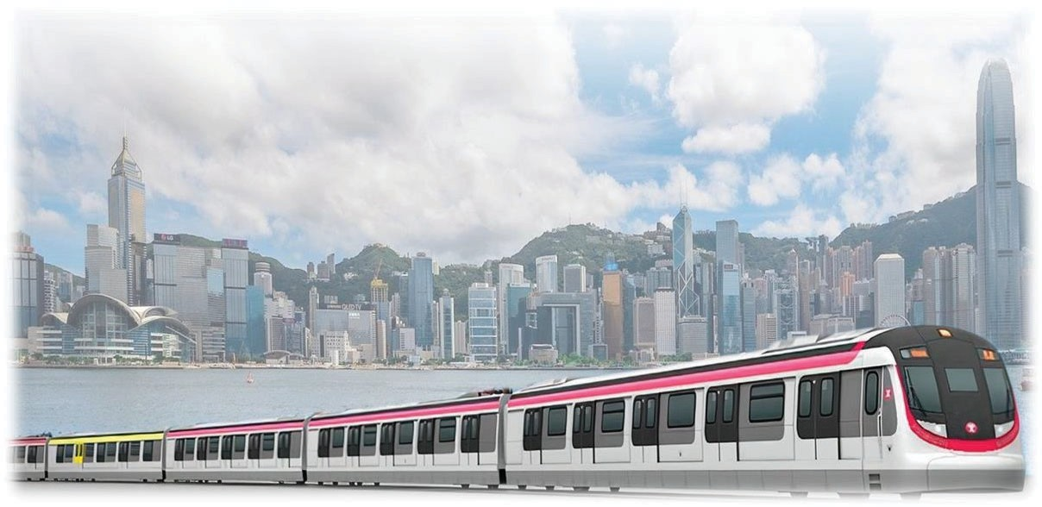**PROJECT INTEGRATED MANAGEMENT SYSTEM (PIMS) NORTHERN LINK**

**PROJECT EXECUTION PLAN [*PIMS/NOL/PEP-001/A1]***

Issue Date: 1 Oct 2023 Page 1 of 27 PIMS/NOL/PEP-001/A1

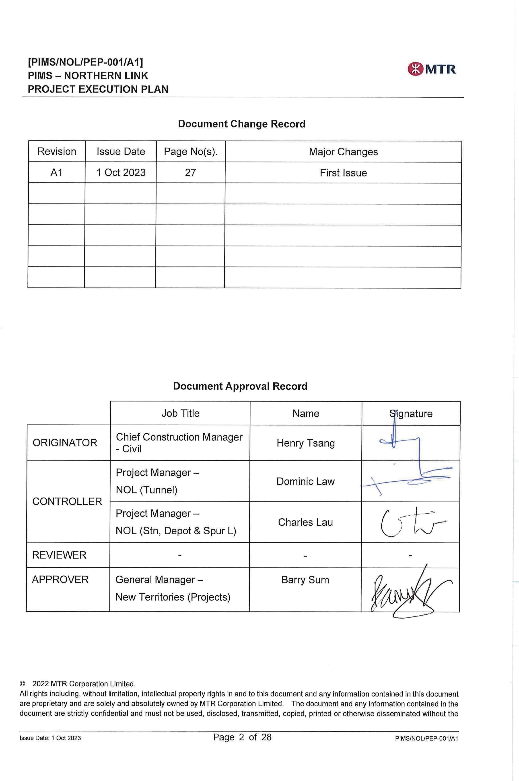

**Contents**

1. Introduction 5
   1. Scope 5
   2. Objectives 5
   3. Ownership and Application 5
   4. Interfaces 6
2. Project Overview 8
   1. Project Objectives 8
   2. Project Scope 9
   3. Key Project Milestones 9
   4. Project Stage Overview 10
   5. Project Agreement 10
   6. Project Contract Strategies 11
   7. Project Organisation 11
   8. Project Definition Documents (PDDs) 12
3. Project Delivery Approach 13
   1. Implementation of PIMS 13
   2. Project Management & Coordination 13
   3. Interface Management 13
   4. Occupational Safety & Health 13
   5. Project Quality Management 13
   6. Environmental Management 14
   7. Stakeholder Engagement 14
   8. Project Delivery Risk Management 14
   9. Programme Management 14
   10. Design Management 14
   11. Construction Management 14
   12. Testing and Commissioning 14
   13. Handover of Completed Works 15
   14. Land Administration 15
   15. Statutory Compliance 15
   16. Information Management 15
   17. Commercial Management 15
4. External Monitoring and Control 15
   1. Project Agreement 15
   2. HyD/RDO and M&V Consultant Monitoring 16

Appendix 1: Project Execution Plan Terms and Roles 17

Appendix 2: Abbreviations 21

Appendix 3: Reference Documents 23

Appendix 4: Project Programmes 25

Appendix 5: Project Management Team Organisation Charts 27

1. Introduction

# Scope

* + 1. This Project Execution Plan (PEP) applies to Northern Link (NOL) and all MTRCL personnel involved in managing the project.
    2. This PEP has been developed for Preliminary Design Stage and shall be further updated prior to commencement of Construction Stage.

# Objectives

* + 1. This PEP is the principal management tool for the General Manager (GM) / Project Manager (PM) to manage the project. It has been developed in accordance with PIMS/PJM/INS-001 Project Execution Plan, and will be reviewed and updated quarterly. This frequency can be extended to yearly at the discretion of the GM, but as a minimum the PEP should be updated and re-issued at the commencement of each project lifecycle stage.
    2. The purpose of this PEP is to:
       - Provide a summary of the project scope, objectives, key milestones and organisation as a reference point for all personnel;
       - Document key project activities, assumptions, risks and interfaces relevant to the specific project stage;
       - Set out the how the General Manager (GM) /Project Manager (PM) will address the key management themes addressed in PIMS/PJM/PRO-001 Project Management Procedure: leadership, partnering, team, interface coordination, management of change, communications, etc.
       - Define how PIMS and wider MTRCL requirements for management of the Northern Link are to be implemented in line with the Project Integrated Management System (PIMS) Policy (PIMS/POL-001); and
       - Summarise any specific project strategies and approaches that have been agreed, with references to related project specific management plans that have been developed where appropriate.

**PIMS/PJM/INS-001 Project Execution Plan**

**PIMS/PRI/POL-001 Project Integrated Management System (PIMS) Policy**

# Ownership and Application

* + 1. This PEP is owned and controlled by the PM – NOL , which would be of ongoing development to reflect the Project Management requirements relevant to each stage of the project lifecycle.
    2. Responsibility for application of this PEP is delegated by GM-NT(P) to PM – NOL.

# Interfaces

* + 1. This section outlines who needs to be engaged with in relation to Project Management requirements for NOL.
    2. Internal Interfaces

The main internal interfaces in relation to Project Management processes for NOL but are not limited to the following:

|  |  |
| --- | --- |
| **WHO** | **HOW and WHY** |
| **Capital Works Technical Management Committee (CWTMC)** | Manages and reviews development of Project Definition Documents (PDDs) for use on Capital Works projects and defines the associated technical audit requirements to verify compliance of individual Projects with the appropriate PDDs. |
| **Project Management Team** | Ensures the project is delivered according to the PDD requirements and within the specific time and budget through the day-to-day First Line of Defence (“1LoD”) activities. |
| **Enabling Functions** | Includes CWBU Technical, PMO, Commercial Management, Chief of Staff and Safety Management Departments.  Provide support to Project Management Team to ensure the project is delivered according to the PDD requirements to expect quality level and within the specific time and budget through the day-to-day support, review, and audit activities.  Develop best practices and processes and provide governance on their respective expert areas.  Specific resources may be allocated to support the PMT as required by the project scope. |

* + 1. External Interfaces

The main external interfaces in relation to Project Management processes for NOL include, but are not limited to the following:

|  |  |
| --- | --- |
| **WHO** | **HOW and WHY** |
| **Buildings Department (BD)** | The Buildings Department (BD) is a department of the Hong Kong Government responsible for building codes, building safety, and inspection. It was founded in 1993 and is now subordinate to the Development Bureau.  According to building regulation, MTRCL will conduct IoE audit and the audit report will be submitted to BD for review and  record. |
| **Electrical and Mechanical Services Department (EMSD)** | The Electrical and Mechanical Services Department is a Hong Kong Government department responsible for inspection and enforcement of operation and safety of many electricity and gas installations; railways and trams; lifts and escalators; amusement rides; working platforms on building sites, and many other diverse areas. The department has two main branches:  Regulatory Services and Trading Services. The department falls |

|  |  |
| --- | --- |
| **WHO** | **HOW and WHY** |
|  | under the purview of the Development Bureau.  The system assurance audits can provide assurance for relevant inspection by EMSD. |
| **Environmental Protection Department**  **(EPD)** | The department of the Hong Kong Special Administrative Region Government entrusted to deal with all regulatory environmental issues arising as a result of existing or proposed infrastructure development.  The environmental audits shall be conducted to fulfill the regulations under EPD. |
| **Fire Services Department (FSD)** | Hong Kong Fire Services Department (HKFSD) of the Government of Hong Kong is an emergency service responsible for fire-fighting and rescue on land and sea. It also provides an emergency ambulance service for the sick and the injured, and gives fire protection advice to the public.  The system assurance audits can provide assurance for FS inspection by FSD. |
| **Geotechnical Engineering Office (GEO)** | The Geotechnical Engineering Office (GEO) is responsible for a wide range of geotechnical engineering activities related to the safe and economic utilization and development of land. It is one of seven constituent offices of the Civil Engineering and Development Department of the Government of the Hong Kong Special Administrative Region.  The 1LoD activities such as settlement monitoring by Project Management Team and technical audits to assure the design  meeting the PDDs and statutory requirements on Geotechnical aspect. |
| **Labour Department (LD)** | Labour Department is a department of the Hong Kong Government responsible for labour dispute mechanisms, employment, occupational health and safety and workforce participation.  The F&IU audits shall be conducted to fulfill the regulation under LD. |
| **Railway Development Office- Highways Department**  **(RDO/HyD)** | The Railway Development Office - Highways Department is responsible for implementation of railway projects and planning Hong Kong’s future railway expansion to support the continued population growth and economic development of the Territory. |
| **Transport Department (TD)** | The Transport Department is under the Transport and Housing Bureau and responsible for administering the Road Traffic Ordinance and legislation for the management of road traffic, regulation of public transport services and operation of major  transport infrastructures in Hong Kong |



1. Project Overview

# Project Objectives

* + 1. The project objectives set out below are related only to NOL Project.
    2. Planning and design for the NOL Project shall take place in an open manner with a high degree of interaction and engagement with the local communities. Care shall be taken to respect local construction noise, dust and waste, landscape and visual impacts, hazards to local residents, as well as potential nuisances during future operations.
    3. The NOL Project shall be designed to attract a high market share of transport within northern New Territories. Integration with surrounding existing/planned new town development areas shall be considered at an early stage. The NOL Project will have sufficient capacity to accommodate the forecast patronage arising from the advance version of 2016-based Territorial Population and Employment Data Matrix (TPEDM) with population adjustment as provided by the Government.
    4. The NOL Project shall be designed to operate 6-car trains initially, increasing to potentially 7-car trains, subject to passenger growth; the full service shall be able to operate at ultimate capacity at a peak hour headway of 2.1 minutes and a non-peak hour headway of 4 minutes in both directions.
    5. Whole life costs shall be addressed during the design and minimized as much as possible, without compromising the ability to attract the forecast patronage. The stations shall also include retail facilities, advertising and digital advertising, and other commercial facilities. Public areas shall be designed to support passenger distribution and enhance connections with the communities, with customers being the focus of station design to ensure their journeys are seamless and pleasurable. Smart Mobility via new digital and smart installations shall be actively pursued to enhance overall customer experience.
    6. Design for Manufacturing and Assembly (DfMA) strategy, precast and prefabrication approaches shall be adopted to minimize time and cost, and at the same time achieving high quality end products. Construction of the NOL Project shall be planned and executed in a manner which minimizes time and cost, as well as disturbance and adverse environmental impacts to the adjacent communities. Construction traffic impact shall be minimized.
    7. Safety during construction and operation of the NOL Project shall be addressed as a key activity during the design and construction stages.
    8. The design and construction shall allow the performance standards, reliability targets and customer service requirements specified in the internal project definition documents to be achieved.
    9. Normal operation of the TML and EAL shall be maintained during the implementation of the NOL Project. Any inconvenience to passengers shall be minimised.
    10. The target completion date for the NOL Project is in 2034, subject to timely receipt of Government and statutory approvals, and handover of the sites for construction.

Following establishment of a confirmed project scope, estimated cost and completion date, the project shall be completed within budget and on time.

* + 1. The required financial rate of return for the NOL Project shall be in accordance with the Corporation’s investment criteria for new rail projects. Funding support from Government shall be required and shall be committed prior to commencement of the construction of the project.
    2. In view of the town planning benefits, enhancement of railway patronage, as well as significant contribution to railway financing, opportunities for railway related property developments shall be actively explored wherever possible and practicable.

# Project Scope

* + 1. The NOL Main Line which involves the construction of a new, fully underground railway line of approximately 10.7km long from the new extension to Kam Sheung Road station (KSR(NOL)) to the Kwu Tung Station (KTU(NOL)) via three intermediate stations at San Tin (SAT), Ngau Tam Mei (NTM) and Au Tau (AUT). The new NOL Main Line also includes construction of Ngau Tam Mei Depot (NTD) to support the operations of NOL Main Line.
    2. There are also a number of Ancillary Buildings (ABs) located along the NOL Main Line that contain a combination of Ventilation Building (VB), Emergency Access Point (EAP) and/ or Emergency Egress Point (EEP).

# Key Project Milestones

* + 1. Key project milestones are summaries below and no delay is identified before the next design stage is commenced.
       - Approve EIA Report by EPD
       - EP issuance by EPD
       - Award Advance Works Contract
       - Railway Scheme Gazetted by TLB
       - Complete Preliminary Design by C1602
       - Railway Scheme Authorised by STLB/CE Council
       - Finalise Project Agreement with Government
       - Government Land Available for Construction
       - Private Land Available for Construction
       - Award Works Contract
    2. Project programmes as of Preliminary Design stage in August 2023 are attached as

**Appendix 4**

# Project Stage Overview

* + 1. In the Preliminary Design stage, the aim is to develop an initial scheme and design options to derive the Preferred Scheme using value engineering techniques. Following this the focus is on the development, delivery and integration of the various input to deliver the Preliminary Design Report. A set of Project Definition Documents (PDDs) will be established in a progressive manner to provide definition of, and agreement to, a set of performance requirements and objectives for NOL project.
    2. The public consultations, pre-consultation of statutory submissions and gazettal process shall be conducted in the Preliminary Design stage to fix a scheme for subsequent Detailed Design. The project scope, cost, programme and contract strategy of the works are also established.
    3. The NEC 4 option X22 on early contractor involvement (ECI) would involve verification of the findings of the Preliminary Design, further development for obtaining all statutory approvals or endorsements related to design, as well as preparation of tender documents providing the Design and Build contractor with details to carry out the Detailed Design, to execute his duties and to construct the Works. The management and maintenance parties for all permanent works shall be identified and agreed with relevant stakeholders, maintenance and management agents on the demarcation.
    4. In the Preliminary Design stage, the key interfaces and dependencies of the NOL are identified as follows:
       - Major new development area including Kwu Tung North New Development Area (KTN NDA), San Tin Lok Ma Chau Development Node (STLMC DN), Ngau Tam Mei Land Use Review Study (NTM LURS), Sha Po Public Housing Development, Kam Tin South Public Housing Development and Kam Ho Road Public Housing Development
       - Kam Tin River, WSD fresh watermains upgrading works near Ngau Tam Mei and Fanling Highway Widening Works
       - Existing KSR (TML) Station, Tuen Ma Line, East Rail Line, Lok Ma Chau Spur Line and High Speed Rail tunnels
       - Future KTU(EAL) Station and NOL Spur Line
       - Kam Sheung Road Package 2 Property Development, Kam Tai Road Residential Development, PARK YOHO and other Private Development along the alignment
       - Connection with potential R+P sites
       - CEDD Site Formation and Infrastructure Works for Public Housing Developments at Kam Tin South, Yuen Long – Phase 1 Contract No. YL/2020/04
    5. Key stakeholders of the project are grouped into the following major categories:
       - Internal: HKTS, Railway Protection
       - Local community: relevant village representatives along NOL alignment, residents
       - Interest groups and environmental: various green groups, NGOs
       - Political: Sheung Shui Rural Committee, San Tin Rural Committee, Kam Tin Rural Committee, Pat Heung Rural Committee, Shap Pat Heung Rural Committee, North District Council, Yuen Long District Council, Legislative Council
       - Government and statutory bodies
       - General public (media)
       - Professional Bodies (i.e. HKIE)

# Project Agreement

* + 1. For the project agreement of the NOL Main Line works, It would be further developed before commencement of construction stage.
    2. For the NOL Advance Works, the scopes and requirements have been defined in the Project Agreement of the Kwu Tung station (KTUPA). The NOL Advance Works shall be constructed in advance of the NOL Main Line works in order to secure and expedite the project programme, as per para. 2.7, Appendix D of KTUPA, the construction of the NOL Advance Works shall be commenced in no event later than December 2024.

# Project Contract Strategies

* + 1. Procurement process for main civil works (including BS and ABWF) shall be in accordance with Procurement Procedure P/P&C/01 starting with an open prequalification exercise, follow with a single stage competitive tender process adopting post contract“Early Contractor Involvement (ECI)” design and build contract

approach by using NEC4 Engineering and Construction Contract - Option C: Target Contract with activity schedule, with Secondary Option X22.

* + 1. List of Major Contracts
       - 1630 - Ground Investigation for Kwu Tung Station for Northern Link
       - 1631 - Ground Investigation for Northern Link (North)
       - 1632 - Ground Investigation for Northern Link (South)
       - 1634 - Horizontal Directional Coring for Northern Link
       - C1602 – Preliminary Design for Northern Link Phase 2
       - C1603 – Environmental Impact Assessment Study for Northern Link
       - C1604 – to be confirmed
    2. List of bundling E&M work contracts related to NOL.
       - To be confirmed

# Project Organisation

* + 1. The latest Project Management Team Organisation Chart for the NOL project management team and the main consultancy team are attached as Appendix 5.

# Project Definition Documents (PDDs)

* + 1. List of project-specific PDDs and the status at start of the Preliminary Design stage are summarised in the below table.

|  |  |
| --- | --- |
| **Document** | **Status at start of Preliminary Design Stage** |
| Project Objectives | Approved |
| Service Requirement Document | Approved |
| Project Agreement | To be prepared |
| Project Cost Estimate and Finance Plan | Tender cost estimate is under preparation |
| Project Programme | Project Implementation Programme approved by PCG and Project Master Programme is drafted for future submission to PCG |
| Final Preliminary Design Report | To be prepared |
| Railway/ Property Interface Control Document | To be prepared |
| Environmental Impact Assessment Report | To be prepared |
| Environmental Permit | To be granted by EPD |
| Building Department Instrument of Exemption (IOE) | To be prepared |
| Functional Requirements Manual | Approved |

1. Project Delivery Approach

# Implementation of PIMS

* + 1. The NOL shall implement PIMS to ensure that all work is completed in accordance with the specified criteria in a consistent and controlled manner, and the CWBU objectives set out in the PIMS Policy achieved.
    2. The purpose of this section of the PEP is to identify how the standard practices defined in the PIMS will be applied, and where necessary adapted, to ensure that specific requirements of the NOL can be understood and fulfilled by all MTR staff concerned.
    3. The NOL project will undertake ongoing Self-Certification throughout the project lifecycle as required by:

**PIMS/PRI/PRO-001 PIMS Management Review & Improvement Procedure**

# Project Management & Coordination

*[To be developed, including:*

* + 1. *Project Resource Management –*
    2. *Management of Consultants / Contractors*
    3. *Project KPIs and Reporting ]*

**PIMS/PJM/PRO-001 Project Management Procedure**

# Interface Management

*[To be developed, including:*

* + 1. Interface Management Plan

**PIMS/STE/PRO-001 Stakeholder Engagement Procedure PIMS/CON/PRO-001 Construction Management Procedure**

# Occupational Safety & Health

* + 1. N/A for this stage

**PIMS/OSH/PRO-001 Occupational Safety & Health Procedure D/PROJ/GEN/H&S/MAN/001 CWBU Health & Safety Management Manual**

# Project Quality Management

* + 1. NOL Project Quality Plan (PQP) is developed to define the application of PIMS, project requirements, applicable quality assurance and quality control activities and the application of the Three Lines of Defence approach.

**PIMS/NOL/PQP-001 Project Quality Plan**

**PIMS/PQA/PRO-001 Project Quality Assurance Procedure PIMS/PRI/PRO-001 PIMS Management Review and Improvement**

# Environmental Management

* + 1. NOL environmental management shall follow the environmental management procedures described in PIMS for each of the Project stages. Project-specific Environmental Management Plan would be developed for the construction stage.

**PIMS/NOL/EMP-001 Project Environmental Management Plan**

# Stakeholder Engagement

* + 1. NOL Project Stakeholder Engagement Plan (SEP) is developed to manage the Stakeholder Engagement process of a project which set out the key objectives of SE, capture and prioritise stakeholders and their issues for formulation of appropriate actions and activities to engage the stakeholders.

**PIMS/NOL/SEP-001 Project Stakeholder Engagement Plan PIMS/STE/PRO-001 Stakeholder Engagement Procedure**

# Project Delivery Risk Management

* + 1. NOL Project Risk Management Plan is developed to set out the specific project delivery risk management requirements for NOL project.

**PIMS/NOL/RMP-001 Project Risk Management Plan PIMS/RSK/PRO-001 Project Delivery Risk Management Procedure**

# Programme Management

* + 1. NOL programme management shall follow the requirements stipulated in PIMS for the Preliminary and ECI stage.

**PIMS/PGM/PRO-001 Programme Management Procedure**

# Design Management

* + 1. NOL design management shall follow the requirements stipulated in PIMS for the Preliminary and Reference Design stage.

**PIMS/DEM/PRO-001 Design Management Procedure**

# Construction Management

* + 1. Construction management of NOL shall follow the requirements stipulated in PIMS.

**PIMS/CON/PRO-001 Construction Management Procedure**

# Testing and Commissioning

* + 1. N/A for this stage

**PIMS/TNC/PRO-001 Testing & Commissioning Management Procedure**

# Handover of Completed Works

* + 1. N/A for this stage

**PIMS/TNC/PRO-001 Testing & Commissioning Management Procedure**

# Land Administration

* + 1. NOL programme management shall follow the requirements stipulated in PIMS for the Preliminary and Reference Design stage. Gazette plans and land requirement plans have been prepared in Preliminary Design stage and scheme gazettal would be made at Reference Design stage.

**PIMS/LAN/PRO-001 Land Administration Procedure**

# Statutory Compliance

* + 1. NOL statutory submission management shall follow the requirements stipulated in PIMS for the Preliminary and Reference Design stage. NOL Project Management Plan (PMP) is drafted for further liaison with government authorities on the Instrument of Exemption (IoE).

**PIMS/STC/PRO-001 Statutory Compliance Procedure**

# Information Management

* + 1. NOL information management shall follow the requirements stipulated in PIMS for the Preliminary and Reference Design stage. BIM Execution Plan for main consultancy has been developed.

**PIMS/PIM/PRO-001 Project Information Management Procedure**

# Commercial Management

* + 1. NOL commercial management shall follow the requirements stipulated in procedures set out by Commercial Management Department for the Preliminary and Reference Design stage.

**P/P&CD/001 Procurement Procedure P/P&CD/002 Contract Administration Procedure**

**P/003A Cast Estimate and Copst Control Procedure for Project Design Phase P/003B Capital Works Cost Control for Project Construction Phase**

1. External Monitoring and Control

# Project Agreement

* + 1. NOL shall implement specific arrangements as set out within the Project Agreement to support the monitoring and control exercised by HyD/RDO and M&V consultant.

# HyD/RDO and M&V Consultant Monitoring

* + 1. Refer to KTUPA Part IX Project Monitoring and Control, the Corporation shall be subject to monitoring and control by the Government to oversee the delivery performance of the KTU Works and the NOL Advance Works. The Corporation shall provide all documents and information as specified in Schedule B to the Government and/ or its appointed consultant(s) by means of access to Common Data Environment (CDE) for sharing the softcopy of the requested relevant documents and information as soon as reasonably practicable.

Appendix 1: Project Execution Plan Terms and Roles

For all standard PIMS, terms, roles and associated definitions refer to:

# PIMS/PRI/INS-006 PIMS Master Schedule of Definitions

The following terms and roles are used across this Project Execution Plan:

**Project Execution Plan terms:**

|  |  |
| --- | --- |
| **Term** | **Description** |
| **BIM Execution Plan** | Project specific document prepared and managed by the Consultant or Contractor explaining how the information aspects of the project will be managed and how the Exchange Information Requirements will be complied with using BIM processes throughout the project. It is equivalent to the “  Information Execution Plan” in NEC4. |
| **Design Standards Manual (DSM)** | This document is organised by design discipline and is the core document governing the detailed design. It contains the lists of international or national or industry standards to be used in the design. Standards, design requirements and practices specific to the Corporation are also included, as are numerical data such as loading and climatic data which relate to the whole railway or project. Information in this document is generic and is updated on a regular basis. |
| **Instrument of Exemption (IoE)** | A document granted by the Building Authority for a particular project under MTR Ordinance (Cap. 556) to state the exemption from the provisions of the Building Ordinance (Cap 123) and the required actions to the railway works in leased land (private land). The exemption is usually confined to those procedures and requirements relating to the appointment of Authorized Person (AP) and Registered Structural Engineer (RSE), approval of plans, consent to the commencement and resumption of works and occupation of buildings. |
| **Project Agreement** | An agreement between the Corporation and the HKSAR Government (or other parties) outlining the terms under which the project will be built and operated.  This is a project-specific document |
| **Project Definition Documents (PDDs)** | A hierarchy of documents which defines the performance requirements and objectives of a particular project. |
| **Project Delivery Risk Register** | A register containing Project Delivery Risks, related to the delivery of the Project. This register will include project-wide Project Delivery Risks and individual or summarized Project Delivery Risks contained within the Consultant and Contractor Risk Registers. |

|  |  |
| --- | --- |
| **Term** | **Description** |
| **Project Environmental Management Plan** | A document specifying an effective site environmental management to be prepared and submitted by the Contractor or Supplier for approval by the ER after consultation with Environment Manager shortly after project construction commencement. |
| **IoE – Project Management Plan – (PMP)** | A document setting out how the project is to be managed, emphasising the project organisation, submission requirements and the level of supervision relevant to the scope of the project. The document shall be submitted to BD / RDO for agreement and shall contain the necessary project information for BD / RDO to support the Instrument of Exemption (IoE) and Instrument of Compliance (IoC) for the project. |
| **Project Quality Plan (PQP)** | The Project Quality Plan shall be established prior to the commencement of the Preliminary Design Stage to define the application of PIMS, project requirements, applicable QA and QC activities and the application of the Three Lines of Defence approach. During the implementation of PQP, GM/PM has the overall accountability for the application and ongoing maintenance to capture any changes of the QA/ QC requirements resulted from lesson learnt, new strategy and needs in subsequent stage. Details shall be referred to PIMS/PQA/PRO-001 Project Quality Assurance Procedure |
| **Project Risk Management Plan** | A document setting out the specific Project Delivery Risk Management requirements for the Project. |
| **Project Stakeholder Engagement Plan (SEP)** | SEP is the principal tool for the project management team to manage the Stakeholder Engagement (SE) process of a project. The SEP shall set out the key objectives of SE, capture and prioritize stakeholders and their issues for formulation of appropriate actions and activities to engage the stakeholders |
| **System Assurance** | System Assurance is a set of engineering activities and management process to assure that the systems to be delivered will be in conformance with all applicable system requirements for reliability, availability, maintainability and safety, and to provide the users with acceptable confidence that the systems will behave as per the operational requirements. |

**Project Execution Plan roles:**

|  |  |
| --- | --- |
| **Role** | **Description** |
| **Chief Construction Manager** | The person responsible for construction management of a  geographic section or system-wide element of a project. The CCM is responsible for providing construction comments to DM |

|  |  |
| --- | --- |
| **Role** | **Description** |
|  | for design submissions prepared by DDC during design and construction stages and managing all consultation submissions and BD full approval submissions prepared by contractor during construction stage. The CCM may take up the role of CP Rep. |
| **Chief Design Manager** | The person responsible for design management of a geographic section or system-wide element of a project. The CDM is responsible for managing all design submissions prepared by Design Consultant (In house or external) during design and construction stages and providing assistance to Chief Construction Manager (CCM) in reviewing contractor ’ s submissions which will be submitted to Building Department  (BD) / Railway Development Office (RDO) / Geotechnical Engineering Office (GEO) for BD full approval /consultation as well as for the approval by other statutory departments such as FSD, EMSD, WSD etc during construction stage. |
| **General Manager – New Territories (Projects)** | The senior management of the Corporation overseeing and managing the planning and execution of a project. Responsible to the CWD for the overall proactive planning and management of specified railway projects and/or any associated capital & revenue works for Operating Railway, ensuring that each railway project and/or any associated capital & revenue works is delivered on time, within budget and to the required construction, safety, quality, environmental standards and stakeholder requirements. The General Manager is also responsible to the CWD for:   1. the project organizational structure, the recruitment and motivation of the Project Team, the procurement and management of consultants and contractors and implementing quality, construction, and operational safety and environmental management procedures; 2. management in compliance with the approved Project Budget; and 3. maintaining the project organization structure including the management of Project staff resources |
| **General Manager – Projects Management Office (GM-PMO)** | The General Manager – Projects Management Office (GMPMO), reporting to CWD, is responsible for Overall project management support for environmental management, programming, quality assurance and quality control, land administration, land surveying, and project delivery risk management for the CWBU. The GM-PMO is also responsible  for setting up the overarching Project Controls Strategy including review & control of PIMS. |

|  |  |
| --- | --- |
| **Role** | **Description** |
|  |  |
| **General Manager – Commercial Management (GM – CM)** | The person to plan and establish the procurement and contract administration services for new railway projects to ensure that the Corporation achieves its commercial objectives and receives value for money. |
| **Project Manager –**  **NOL** | Appointed to control, lead and manage each respective Project Management Team. The person responsible for the overall management and implementation of one or more new projects to deliver on time, within budget and to the required quality and safety standards. |
| **Project Management Team (PMT)** | A Team led by a GM / PM for the design and delivery of project(s). |
| **Stakeholder** | Stakeholders are those individuals or groups who have an interest or role in, or who may potentially be impacted by, the railway projects, major pedestrian link projects and major improvement works to the existing railway network undertaken by the Capital Works Business Unit. This may include internal Stakeholders (such as Hong Kong Transport Services Business Unit as an End User) and external stakeholders (such as Government Bureau and Departments (e.g. Transport and Logistics Bureau, Highways Department, Buildings Department, Transport Department, Environmental Protection Department etc) as well as members of the public, members of the legislature, District Councils, area/rural committees, owners’  committees, political parties, community groups, nongovernment organizations and professional institutions. |

Appendix 2: Abbreviations

|  |  |
| --- | --- |
| **Abbreviation** | **Definition** |
| **1LoD** | First Line of Defence |
| **CCM** | Chief Construction Manager |
| **CDM** | Chief Design Manager |
| **CPQM** | Chief Project Quality Manager |
| **CWTMC** | Capital Works Technical Management Committee |
| **ECI** | Early Contractor Involvement |
| **ERR** | Environmental Review Report |
| **NOL** | Northern Link |
| **KTU NDA** | Kwu Tung New Development Area |
| **GM** | General Manager |
| **IoE** | Instrument of Exemption |
| **NGO** | Non-Government Organisation |
| **NTH** | Non-traffic hour |
| **PDDs** | Project Definition Documents |
| **PEP** | Project Execution Plan |
| **PIMS** | Project Integrated Management System |
| **PM** | Project Manager |
| **PMT** | Project Management Team |
| **PQP** | Project Quality Plan |
| **PQT** | Projects Quality Team |
| **R+P** | Rail plus Property |
| **SEP** | Stakeholder Engagement Plan |
| **TLB** | Transport and Logistics Bureau |
| **EAL** | East Rail Line |

|  |  |
| --- | --- |
| **TPEDM** | Territorial Population and Employment Data Matrix |
| **VEP** | Variation of Environmental Permit |

Appendix 3: Reference Documents

**PIMS References:**

Policy:

* + - * **PIMS/PRI/POL-001 Project Integrated Management System (PIMS) Policy**

Procedures:

* + - * **PIMS/CON/PRO-001 Construction Management Procedure**
      * **PIMS/DEM/PRO-001 Design Management Procedure**
      * **PIMS/ENV/PRO-001 Environmental Management Procedure**
      * **PIMS/GOV/PRO-001 Project Governance Procedure**
      * **PIMS/HCW/PRO-001 Handover of Completed Works Procedure**
      * **PIMS/LAN/PRO-001 Land Administration Procedure**
      * **PIMS/OSH/PRO-001 Occupational Safety & Health Procedure**
      * **PIMS/PGM/PRO-001 Programme Management Procedure**
      * **PIMS/PIM/PRO-001 Project Information Management Procedure**
      * **PIMS/PJM/PRO-001 Project Management Procedure**
      * **PIMS/PRI/PRO-001 PIMS Management Review & Improvement Procedure**
      * **PIMS/PQA/PRO-001 Project Quality Management Procedure**
      * **PIMS/RSK/PRO-001 Project Delivery Risk Management Procedure**
      * **PIMS/STC/PRO-001 Statutory Compliance Procedure**
      * **PIMS/STE/PRO-001 Stakeholder Engagement Procedure**
      * **PIMS/TNC/PRO-001 Testing & Commissioning Management Procedure**

Instructions:

* + - * **PIMS/PRI/INS-006 PIMS Master Schedule of Definitions**
      * **PIMS/PJM/INS-001 Project Execution Plan Process**

Guidance Notes

* + - * **Nil**

**Templates and Forms:**

* + - * **Nil**

**Internal References (Excluding PIMS):**

* + - * **D/PROJ/GEN/H&S/MAN/001 CWBU Health & Safety Management Manual**
      * **P/P&CD/001 Procurement Procedure**
      * **P/P&CD/002 Contract Administration Procedure**
      * **P/003A Cost Estimate and Cost Control Procedure for Project Design Phase**
      * **P/003B Capital Works Cost Control for Project Construction Phase**

**Project Document References:**

* + - * **PIMS/KTUEAL/PQP-001 Project Quality Plan**
      * **PIMS/KTUEAL/RMP-001 Project Risk Management Plan**
      * **PIMS/KTUEAL/SEP-001 Project Stakeholder Engagement Plan**
      * **[Project Doc Ref] Land Requirements Plan (available after gazette)**

Appendix 4: Project Programmes

Northern Link

|  |  |  |
| --- | --- | --- |
| Project Implementation Programme | Progress Update (Aug 23) | 31 August 2023 |

**Activity Description Start Finish**

**2020**

**Time Now**

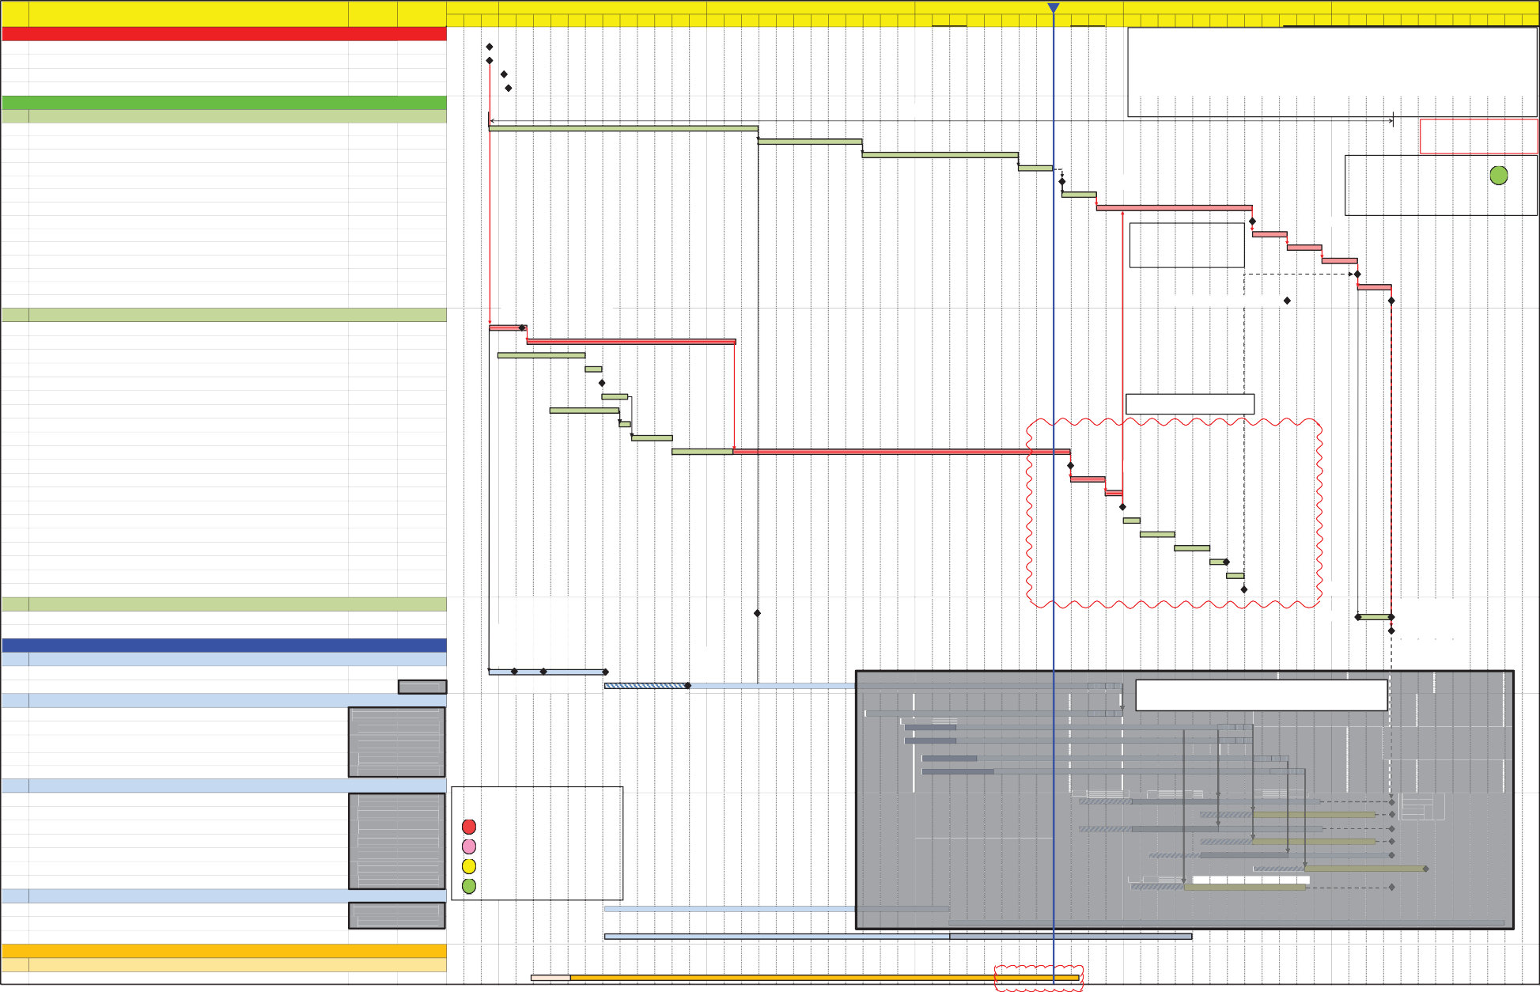**2021 2022 2023 2024 2025**

**1. Project Definition / Agreement with Government**

**Oct Nov Dec Jan Feb Mar Apr May Jun Jul Aug Sep Oct Nov Dec Jan Feb Mar Apr May Jun Jul Aug Sep Oct Nov Dec Jan Feb Mar Apr May Jun Jul Aug Sep Oct Nov Dec Jan Feb Mar Apr May Jun Jul Aug Sep Oct Nov Dec Jan Feb Mar Apr May Jun Jul Aug Sep Oct Nov Dec**

**Key Assumptions:**

1.1

1.2

1.3

1.4

Gov. confirmed to proceed with detailed planning and design Policy Support

Present to Executive for the budget Present to Board for the budget

16-Dec-20 (A)

16-Dec-20 (A)

11-Jan-21 (A)

19-Jan-21 (A)

1. VO issued to Technical Study Consultant to carry out Ecological Study (AECOM)
2. 5 Detailed Design Consultancies (excluding KTU)
3. 7 Construction Contracts (excluding KTU)
4. Includes additional 4 months for Design Check by Gov. (2M + 2M with allowance
5. **Statutory Process**
   1. **Scheme Gazettal and Authorization (NOL Phase 2)**
      1. Public Engagement Exercise 16-Dec-20 (A) 31-Mar-22 (A)
      2. RDO agreement on Draft Gazettal document 01-Apr-22 (A) 16-Sep-22 (A)
      3. Gazette circulation within Government 16-Sep-22 (A) 23-Jun-23 (A)
      4. THB Paper Preparation 01-Jul-23 30-Aug-23
      5. Scheme Gazette (NOL Phase 2) 15-Sep-23

**NOL Phase 2 : 52 months**

Gazette (NOL2)

for one re-submission in each stage)

Critical Path KPI

**Confidential**

**CP**

Scheme objection period

Resolution of objections to the Scheme Scheme Amendment

Scheme objection period

Resolution of objections to the Scheme ExCo's consideration of the Scheme Scheme Authorisation (NOL Phase 2) Preparation of Project Agreement

16-Sep-23

16-Nov-23

16-Aug-24

16-Oct-24

16-Dec-24

16-Feb-25

15-Nov-23

15-Aug-24

15-Aug-24

15-Oct-24

15-Dec-24

15-Feb-25

15-Feb-25

15-Apr-25

Note: EIA report for public inspection 1.5 month after scheme objection.

Scheme Amendment

Critical Path Status

Scheme Authorisation (NOL2)

0.0 Month

Finalization of Project Agreement

15-Apr-25

11/2 Present to PCG

Gov to issue draft PA to MTR

Project Agreement (NOL2)

* 1. **Environmental - EIA Report and EP (NOL Phase 2)**

procurement of consultancy

2.2.A

2.2.B

2.2.C

2.2.D

2.2.E

2.2.F

2.2.G

2.2.H

2.2.I

2.2.J

2.2.K

VO Preparation and Approval for Ecological study Ecological study

Prepare Project Profile (NOL2)

Agree Project Profile (NOL2) with EPD Submit Project Profile (NOL2) to EPD EPD prepare and issue Study Brief Prepare EIA Consultancy SoS

Review and agree EIA Consultancy SoS Tender & Award EIA Consultant Conduct EIA Study & Prepare Report Submit EIA Report to EPD

17-Dec-20 (A) 19-Feb-21 (A)

20-Feb-21 (A) 20-Feb-22 (A)

01-Jan-21 (A) 01-Jun-21 (A)

02-Jun-21 (A) 30-Jun-21 (A)

30-Jun-21 (A)

01-Jul-21 (A) 15-Aug-21 (A)

01-Apr-21 (A) 30-Jul-21 (A)

01-Aug-21 (A) 20-Aug-21 (A)

23-Aug-21 (A) 05-Nov-21 (A)

05-Nov-21 (A) 30-Sep-23

30-Sep-23

Submit Project Profile

To be endorsed by PCG.

Submit to EPD

2.2.L

2.2.M

2.2.N

2.2.O

2.2.P

2.2.Q

2.2.R

2.2.S

2.2.T

EPD Review EIA Report Update EIA Report

EIA Report (Available for Public Inspection) Public Inspection & Comment (NOL2) Advisory Council on Environment Review

EPD Request / Project Proponent to provide Information EIA Approve Report (NOL2)

EPD Issue Environmental Permit EP Issued (NOL2)

01-Oct-23

01-Dec-23

01-Jan-24

01-Feb-24

01-Apr-24

01-Jun-24

01-Jul-24

1. Nov-23
2. Dec-23

31-Dec-23

31-Jan-24

31-Mar-24

31-May-24

1. Jun-24
2. Jul-24

31-Jul-24

Available for Public Inspection

EIA Report Approved

EP Issued (NOL2)

* 1. **Land Acquisition and Resumption**

Submit Land Requirement Plan

Execution of STTs

2.3.A

2.3.B

Government Land Possession and land clearance (NOL2)

Works Commencement (NOL2)

16-Feb-25

15-Apr-25

15-Apr-25

(LRP) & Clearance Application Form (CAF) to LandsD

Finalization of STTs

by LandsD

1. **Design and Procurement**

28/1 Present to PDLT 6/7 Present to

Works

* 1. **Preliminary Design**

3.1.A Prepare SoS and Appoint Design Consultant (NOL2) 16-Dec-20 (A) 06-Jul-21 (A)

procurement of consultancy

Board for the award

Gov't final decision on alignment

Commencement (NOL2)

3.1.B

Preliminary Design (NOL2)

06-Jul-21 (A)

1. Dec-23

17/3 TB to approve

Tenderers List

Railway alignment

**A B C**

* + Procurement strategy to be reviewed.
  1. **Detailed Design (Tentative)**

3.2.A

3.2.B

3.2.C

3.2.D

3.2.E

C1602 - Detailed Design (NOL2 - PHD Modification) (VO to Preliminary Design Consultant) C1605 - Detailed Design (NOL2 - NTM to KTU Tunnel and SAT Station)

C1606 - Detailed Design (NOL2 - KSR to NTM Tunnel, Pok Wai to NTS Tunnel, AUT, NTM Station)

C1607 - Detailed Design (NOL2 - PHD to KSR Tunnel and KSR Station) C1608 - Detailed Design (NOL2 - NTS Depot)

06-Octt-22 (A)

10-Mar-23

10-Mar-23

15-Apr-23

15-May-23

31-Dec-23

15-Aug-24

15-Aug-24

15-Oct-24

15-Nov-24

options development

Tender & Award

**A B C**

**A B C**

**A B C**

**A B C**

**A B C**

* 1. **Works Contract Procurement (Tentative)**

Pre-quallificatiion

Stage 1 Tender

Stage 2 Tender

3.3.A

3.3.B

3.3.C

3.3.D

3.3.E

3.3.F

3.3.G

1605A - NTM to KTU Tunnel (Tentative) 1605B - SAT Station (Tentative)

1606A - KSR to NTM Tunnel and Pok Wai to NTS Tunnel (Tentative) 1606B - AUT and NTM Stations (Tentative)

1607 - PHD to KSR Tunnel and KSR Station (Tentative) 1608 - NTS (Tentative)

1602 - Wetland Compensation (Tentative)

16-Oct-23

1. May-24
2. Oct-23

15-May-24

15-Feb-24

15-Aug-24

15-Jan-24

15-Dec-24

15-Mar-25

15-Dec-24

15-Mar-25

15-Apr-25

15-Jun-25

15-Nov-24

**Critical Path KPI Legend:**

**CP** Delay not recoverable

**CP** Behind Schedule (>4months)

**CP** Behind Schedule (<4months)

**CP** Steady Progress

Pre-Qualification Tendering & Tender Assessment

Contract Award

* 1. **MTR In-house E&M Design**

3.4.A

3.4.B

3.4.C

Scheme Design Reports for All E&M Systems

Review Civil/BS Technical Spec. and Prepare IRS, etc. for NOL2 Prepare and Submit Cost Estimate for All Systems to RDO

06-Jull-21 (A)

01-Mar-23

06-Jul-21 (A)

28-Feb-23

31-Oct-25

30-Apr-24

Preliminary Cost Estimate

Final Cost Estimate

1. **Ground Investigation Works**
   1. **1631, 1632 & 1634 – Ground Investigation for Northern Link**

4.1.A Fieldworks and Test Reports (NOL Ph 2) 03-Mar-21 (A) 15-Oct-23

Tender & Award

Additional scope to be endorsed by PCG

|  |  |  |  |  |  |  |  |  |  |  |  |  |  |  |  |  |  |  |  |  |  |  |  |  |  |  |  |  |  |  |
| --- | --- | --- | --- | --- | --- | --- | --- | --- | --- | --- | --- | --- | --- | --- | --- | --- | --- | --- | --- | --- | --- | --- | --- | --- | --- | --- | --- | --- | --- | --- |
| **Trend** | **2023** | | | | | | | | | | | | | **2024** | | | | | | | | | | | | | | | | |
| **Jan** | **Feb** | **Mar** | | **Apr** | **May** | **Jun** | **Jul** | **Aug** | **Sep** | **Oct** | **Nov** | **Dec** | **Jan** | **Feb** | **Mar** | **Apr** | **May** | **Jun** | **Jul** | **Aug** | | **Sep** | | **Oct** | | **Nov** | | **Dec** | |
| **Critical Path Status (Months)** | 0.0 | 0.0 | 0.0 | | 0.0 | 0.0 | 0.0 | 0.0 | 0.0 |  |  |  |  |  |  |  |  |  |  |  |  | |  | |  | |  | |  | |
| **Critical Path KPI** |  |  |  | |  |  |  |  |  |  |  |  |  |  |  |  |  |  |  |  |  | |  | |  | |  | |  | |
|  | Legend:  A: Design Check by Gov B: Prepare re-submission C: Design check by Gov | | | **NORTHERN LINK MAIN LINE (NOL)**  **Project Implementation Programme** | | | | | | | | | | | | | | | | | | Programme No.: NOL2/PIP/1000/5 | | | | | | | | |
| Date | | Revision | | Prepared | | Checked | | Approve |
| 17-Jun-21 | | Rev. 5 | | CF | | RL | | PCG |
| 30-Apr-23 | | Progress Update (Apr 23) | | KC | | CF | |  |
| 31-May-23 | | Progress Update (May 23) | | KC | | CF | |  |
| 30-Jun-23 | | Progress Update (Jun 23) | | KC | | CF | |  |
| 31-Jul-23 | | Progress Update (Jul 23) | | KC | | CF | |  |
| 31-Aug-23 | | Progress Update (Aug 23) | | KC | | CF | |  |

202308_NOL PIP_Ph2 (Rev 5)_Monthly Report.xlsm 30/08/2023

|  |  |  |
| --- | --- | --- |
| **A** | **B** | **C** |

**[PIMS/NOL/PEP-001/A1] PIMS – NORTHERN LINK PROJECT EXECUTION PLAN**

Appendix 5: Project Management Team Organisation Charts

Issue Date: 1 Oct 2023 Page 27 of 27 PIMS/NOL/PEP-001/A1

**Confidential**

Organisation Chart for NOL at Preliminary Design Stage

As at 11 Sep 2023

**Barry Sum**

GM-NT (Projects**)**

**Alison Lee** Executive Secretary

**Full time Part time**

**Roll-up cost center only**

**Cat Lee** Executive Secretary

**Ken Lee**

Head of Design

**Wency Mo** Executive Secretary

**Dominic Law**

PM(NOLT

**Charles Lau**

PM-NOL(SD&S)

**Design Management**

E&M

**NOL-2 Design Management**

**Virginia Kwok** Secretary

**Manyi Wong AA**

**Ralph Tam**

CDM (NOL)

**Louis Lau**

CCM - BS

**Joseph Lor**

CDM (NOL2)

**Ling Chan**

AA

**Crystal Ip**

AA

**Winnie Tsang** AA

**Anthony Au**

CDM (NOL2)

**C&S**

**Irene Liu**

SDM

**Arch**

**#Johnson Lin** SPArchM

**BIM/**

**CADD**

**BS**

**Lee**

**Kevin**

SDM

**Pway & OHL**

**Marco Li**

CCM

**C&S**

**Stephen Lee** SDM

**C&S**

**TBC**

SDM

**C&S**

**Sharon Tsang** SDM

**C&S**

**Wilson Wong** SDM

**Arch**

**Florence Hui** SPjAM

**Arch**

**Rahim Abdul** SPjAM

**BIM/C ADD**

**BS**

**Gary Ho** SCM

**Silvia Lam** SDME

**Tong Man Man** SDME

**Donna Wai** Atg. SDME

**Timothy Wong**

Sr Pj Architectural

Designer

**Hanson Chan** PIM-Mgr

**Kevin Lam** SConE

**Kelvin Wong** SConE

**(TBA) SDME**

**Maggie Ho**

SDME

**Alex Fang**

SDME

**Tracy Tsui**

SDME

**Humphrey Kwok** SDME

**Lok Chan**

SDME

**George Fung**

SDME

**Jimmy Fung** SPjA

**Helen Zhang** SPjA

**Hanson Chan** PIM-Mgr

**Calvin Wong** SDME

**Sabrina Fung** PjA

**Christine Wong DME**

**Jeanie Tang** PjA

**Niko Chan** PIM-E

**Judy Choi** DME

**Jenny Lau**

PjA

#shared resources

**CL Wong**

CADD

Specialist

Tunnel & Ancillary Buildings

**Kannie Chon**

CADD Specialist

KSR, AUT, NTM, NTD & Alignment

SAT

KSR, PHD &

Stabling Sidings

NTM, SAT &

Ancillary Buildings

**Yan Cheung**

PIM-Support E

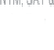

MTR Corporation

**NOL Mainline Organisation Chart (As of 2023)**

ES

AS x 1 + AA x 1 + OA x 1

E Sec x 1

PM-NOL(SD&S)

PM-NOL (T)

HoD

E Sec

GM-NT (Projects)

Design (with supported by E&M)

Civil

Enabling Functions

|  |  |  |  |  |  |  |  |  |  |  |  |  |  |  |  |  |  |  |  |  |  |  |  |  |  |  |  |  |  |  |  |
| --- | --- | --- | --- | --- | --- | --- | --- | --- | --- | --- | --- | --- | --- | --- | --- | --- | --- | --- | --- | --- | --- | --- | --- | --- | --- | --- | --- | --- | --- | --- | --- |
|  | | | | | | | | | | | Utilities |  | Liaison |  | CR |  | Environmental |  | Commercial |  | Quality |  | Programming |  | Geotechnical |  | Safety |  | Project Risk |  | Land Admin |
|  |  |  |  |  |  |  |  |  |  |  |  |  |  |  |  |  |  |  |  |  |
| M30 | CDM x 3 |  |  |  |  |  | CCM x 1 |  |  |  |  |  |  |  |  |  |  |  | CPCM x 1 |  |  |  | CPrgM x 0.4 |  | SE-G x 0.25 |  |  |  |  |  |  |
|  |  |  | Sec x 1, AA x 4 |  |  |  |  |  | AA x 1 |  |  |  |  |  |  |  |  |  |  |  |  |  |  |  |  |  |  |  |  |  |  |
|  |  |  |  |  |  |  |  |  |  |  |  |  |  |  |  |  |  |  |  |  |  |  |  |  |  |  |  |  |  |  |  |
| M20 | SDM-C x 7 |  |  |  | SProjAM x 2.5 |  | SCM-C x 1 |  |  |  | SUM x 0.1 |  | SLM x 1 |  | SCCM-CW |  | SEM x 1.15 |  | SPCM x 4 |  | QAM x 0.8 |  | SPrgM x 1.4 |  | SE-G x 0.5 |  | SPSM x 1 |  |  |  | SLAM X 0.25 |
|  |  |  |  |  |  |  |  |  |  |  |  |  |  |  |  |  |  |  |  |  |  |  |  |  |  |  |  |  |  |  |  |
|  |  |  | BIM |  |  |  |  |  |  |  |  |  |  |  |  |  |  |  |  |  |  |  |  |  |  |  |  |  |  |  |  |
| M10 | SDME-C x 9 |  | M-PI x 1 |  | SPjA x 3 |  | SConE-C x 3 |  |  |  | SUE x 0.3 |  | SLE x 2 |  | CCM-CW |  | SEE x 1.25 |  | SCE x 4 |  | SQAE x 0.67 |  | SPrgE x 1.2 |  | SE-G x 1.5 |  | SCSA x 1 |  | PRM x 0.4 |  | LAM x 0.25 |
|  |  |  |  |  |  |  |  |  |  |  |  |  |  |  |  |  |  |  |  |  |  |  |  |  |  |  |  |  |  |  |  |
| S40 | DME-C x 1 |  | E-PI x 1 |  | ProjA x 3 |  |  |  | SIOW x 1 |  |  |  | LE x 2 |  | ACCM-CW |  | EE x 1.4 |  | CE x 5 |  | QAE x 1 |  | PrgE x 0.2 |  | E-G x 1.5 |  | CSA x 2 |  | PRE x 0.4 |  | LAE x 0.25 |
|  |  |  |  |  |  |  |  |  |  |  |  |  |  |  |  |  |  |  |  |  |  |  |  |  |  |  |  |  |  |  |  |
| S30 |  |  | Supp E PI x 1 |  | CADD x 2 |  |  |  | IOW x 1 |  |  |  |  |  | SCCE-CW |  |  |  | CSE x 4 |  |  |  |  |  |  |  |  |  |  |  | LAEAx 0.25 |
|  |  |  |  |  |  |  |  |  |  |  |  |  |  |  |  |  |  |  |  |  |  |  | | | | | | | | | |
| S20 |  |  |  |  |  |  |  |  | AIOW x 3 |  |  |  |  |  | CCE-CW |  |  |  |  |  |  |
|  |  |  |  |  |  |  |  |  |  |  |  |  |  |  |  |  |  |  |  |  |  |
| S10 |  |  |  |  |  |  |  |  |  |  |  |  |  |  | SCCA |  |  |  |  |  |  |
|  |  |  |  |  |  |  |  |  |  |  |  |  |  |  |  |  |  |  |  |  |  |
| G40 |  |  |  |  |  |  |  |  |  |  |  |  | AA x 1 |  |  |  |  |  | AA x 1 |  | AA x 0.53 |

Legends:

Shared resources under NT

NOL2